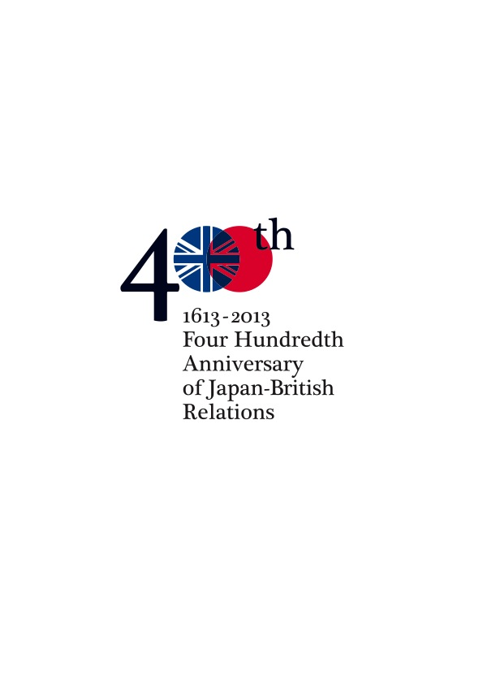

September 5, 2013

PRESS RELEASE

Marking 400 years of trade relations with Japan

Japan400 has commissioned a brand new telescope by the renowned British maker Ian Poyser to commemorate the 400th anniversary of King James I’s similar gift to the First Shogun in 1613.

The custom-made Japan400 telescope will be viewed for the first time at a special gathering at the Royal Armouries’ ancestral home, the White Tower within the Tower of London, at 6.30 pm on Monday (September 9), hosted by the Chairman of the Royal Armouries, Wesley Paul.

Among those present will be senior diplomats from the Japanese Embassy, the Japan400 Co-Chairmen Professor Timon Screech and Nicolas Maclean, as well as Akira Matsura, the Head of the Matsura Historical Museum in Hirado and a descendant of the ruler of Hirado in southwestern Japan who first welcomed the British 400 years ago and Lord Salisbury, whose ancestor the first Lord Salisbury, as Chief Minister to King James, organised the first mission to Japan, including its far-sighted gift of a telescope.

Other special guests will include Manan Bhansali, Vice-President Operations of the East India Company, Takaaki Hanaoka, Secretary General of the Japanese Chamber of Commerce and Industry in the UK, Yuichiro Hanyu, Director of the Japan Local Government Centre in London, and Tetsuya Shirasaki, Managing Director, of the Council of Local Authorities for International Relations (CLAIR) from Tokyo.

The viewing will take place alongside the Japanese armour which was given to James I as a reciprocal gift 400 years ago by Tokugawa Hidetada, the Second Shogun, and which now forms part of Royal Armouries’ national collection.

The new telescope is being offered by Japan 400, to commemorate the start of diplomatic, trading, scientific and cultural relations between Britain and Japan in 1613. Through a host of exciting events during 2013, it celebrates the spirit of discovery and mutual regard that has inspired many successful collaborations and a remarkable friendship between two societies on opposite sides of the world.

The cost of the Japan400 telescope, its tripod and wooden presentation cabinets has been donated by Mr Robin James Maynard, a British businessman resident in Japan for 35 years. In 2010 he was designated an honorary member of the British Chamber of Commerce in Japan. His extended family has had business links with Japan since the late 1800s.

The 2013 instrument is an astronomical piece in the style of the traditional British brass telescope. It has been made by I. R. Poyser.

Britain has long been renowned for its telescope-making and Ian Poyser is a craftsman continuing that tradition. He has been making astronomical telescopes for over 30 years and since 2002 has specialised in brass telescopes on oak stands.

Timon Screech, Professor of the History of Art and Head of the School of Arts at SOAS, University of London, explains the events which led to this 400th anniversary:

“On 18 April 1611, the eighth voyage of the East India Company left London under the command of John Saris. Of the three ships, one ship, the Clove, Saris’ flagship, was the first British ship to arrive in Japan. On board, among commercial items, was a fine illuminated letter from King James, intended for the Japanese ruler, but with the name left blank for Saris to fill in once he learned his correct name and title. This ruler was Tokugawa Ieyasu, the first Shogun, by this time in retirement, though still leading the country.

“There were also gifts from King James, and the principal one was a telescope.

“The telescope had been invented in Holland some time in 1608. It was used by Galileo in July 1609, and published in his famous Starry Messenger, in March 1610. But one month earlier, the first telescopes were being produced in London, under the name of ‘prospective glasses’. The word ‘telescope’ was agreed by international convention on 14 April, 1611, but in Italy, just four days before the voyage sailed - so before Saris could have known.

“The telescope was Europe’s newest invention, thought almost magical in its power. Those who had heard only rumours, claimed you could see heaven with it, or that the King of France could view all London with one he had in Calais.

“The telescope on the Clove was the first ever to leave Europe.

“Saris arrived in Japan in summer 1613 and delivered the telescope to Tokugawa Ieyasu on September 8.

“The instrument is now lost, but the records show that successive shoguns asked for European telescopes, attesting to their interest.”

Notes to editors

- Royal Armouries has sites in Leeds, HM Tower of London, Fort Nelson and Louisville, Kentucky. It is the first British national museum to open a permanent presence in another country. For more information, please visit www.royalarmouries.org

- For more information about Japan400, please visit www.japan400.com

- Please see quotes made at the time below:

‘Thus forever and ever, we will, we avow, communicate with Japan without any sense of distinction of separation.’
(King James to retired Shogun Tokugawa Ieyasu)

‘Though separated by ten thousand leagues of clouds and waves, our territories are, as it were, close to each other.’
(retired Shogun Tokugawa Ieyasu to King James)

