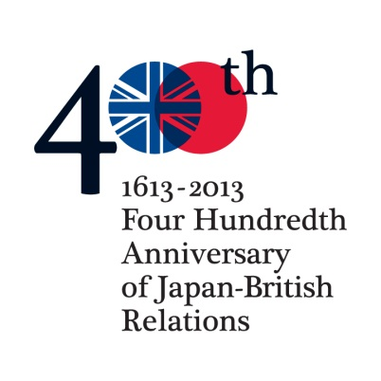
PRESS RELEASE 3 June 2013 www.japan400.com
A Voyage Through Words and Music: Britain, Japan and the Sea
A 400th anniversary celebration of the first formal contacts between Britain and Japan explores the “special relationship” between two island nations

ON Tuesday 11 June AT All Saints Church, Fulham, Church Gate, SW63LA, on Putney Bridge north side (MAP: http://www.qype.co.uk/place/273941).
Doors open from 6:30pm; Programme starts at 7:30pm.
The first British ship ever to reach Japan’s shores arrived on 11th June 1613. Exactly 400 years later - on Tuesday 11th June 2013 - we celebrate this significant historical event with a unique evening of Words and Music in All Saints Church Fulham, the place where the Commander of that ship, The Clove, lies buried.
The relationship between Britain and Japan began with an exchange of precious gifts and fulsome pledges of friendship between their highest rulers. Today those ties are growing and flourishing in the arts and modern culture, the exchange of knowledge and ideas, trade and global affairs, and countless human contacts and collaborations. The differences, too, are often a source of inspiration. The Japan400 team presents a lively evening of celebration, with music, readings and poetry evoking the special character of the Japan-British relationship through time, and the two peoples’ attitudes to the sea.
Leading British and Japanese musicians will perform a unique programme of sea shanties and folk songs from both countries, and music on Japanese koto, shamisen and shakuhachi as well as western instruments. Participants including journalist Evan Davis will read memorable extracts from the ship’s log, travelers’ writings from then and now, and poetry from both literary traditions inspired by the sea.
The artists are generously donating their time to this performance. The sake company Gekkeikan, wine-maker Suntory and East India Company will supply drinks. Funds raised will go to the All Saints Church Restoration Fund and Japan400 Legacy Fund to restore the tomb of John Saris, the leader of that first expedition to Japan – so preserving the memory of a pioneering voyage across ‘ten thousand leagues of clouds and waves’.
London is proud of its tradition of openness to the world. This event celebrates that outlook, and the enriching cultural encounter between Britain and Japan.
Please register Press attendance at this Event to William Horsley AND Sue Hudson on responses@japan400.com; urgent calls only to 07711 912499

